Title: **Number Conversion and Logic Diagrams** Test: 4

Course: Introduction to Automation Unit: Introduction to PLC CLO: 4

Name ANSWER KEY Grade 40pts. Date ______________

**Objectives**

1. Student shall calculate the correct number conversion base on a number from a different number base system.
2. Student shall draw the output of an instruction given its input(s).

**Assessment**

Students shall demonstrate a comprehension of the objectives listed above by scoring a minimum of 75% on this Test. Grading shall be based on the answer key.

**Instructions**

Convert the following octal numbers to their decimal equivalents.

1. 348 2810
2. 108 810
3. 518 4110
4. 78 710
5. 1218 8110
6. 178 1510
7. 738 5910
8. 118 910
9. 1108 7210
10. 2018 12910

**Instructions**

Convert the following decimal numbers to their octal equivalents.

1. 3510 438
2. 1810 228
3. 5310 658
4. 710 78
5. 12110 1718
6. 1810 228
7. 8810 1308
8. 1210 148
9. 11110 1578
10. 11210 1608

Fill in the appropriate letter based on the graphic below.



1. Word D
2. Nibble B
3. Byte C
4. Bit A
5. A QWORD can store larger numbers than a DWORD.
   1. True
   2. False
6. How does a signed integer one word in length indicate that it is a negative number?
   1. Bit 0 is set to a 1
   2. Bit 8 is set to a 1
   3. The MSB is true
   4. None of the above
7. The least significant bit, or LSB is represented by?
   1. Bit 1
   2. Bit 0
   3. Bit 15
8. Does this online view of a rung have logical continuity? Why or why not? (3pts) Yes

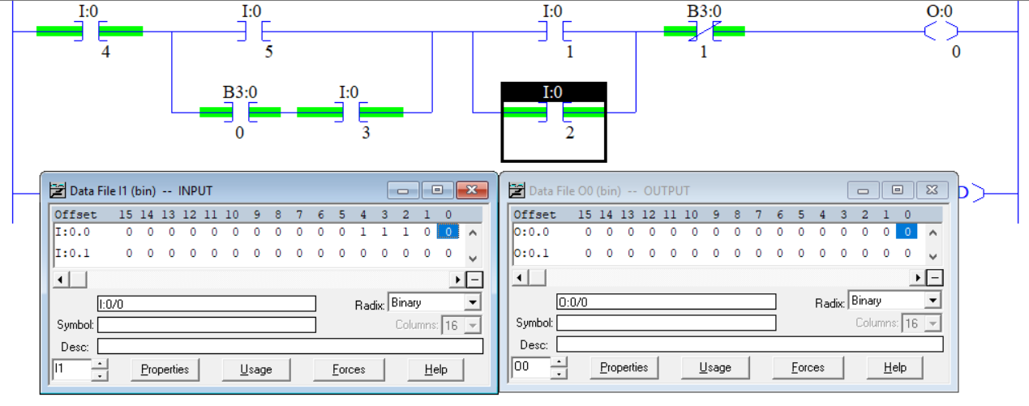

Select the best answer to each multiple-choice question below.

1. A CTU would be used to?
   1. Timing a specific set of contacts
   2. Be a Clock timer unit
   3. Counting up to a certain Preset
   4. Counting down to a certain Preset
2. A CTD would be used to?
3. Each time the rung obtains continuity, an accumulated value is decremented
4. Subtract two numbers until they equal each other
5. Counting up to a certain Preset then setting the done bit
6. Is used to test for a 0 and sets the Accum value
7. Fill in the state of each timer bit (0 or 1).

|  |  |
| --- | --- |
|  | EN 1  TT 0  DN 1 |
|  |  |

1. Fill in the state of each timer bit (0 or 1).

|  |  |
| --- | --- |
|  | EN 1  TT 0  DN 1 |

1. What describes an Integer?
2. A whole number
3. Any number that doesn’t have a fraction
4. Is negative or positive
5. All the above
6. The ladder logic below is offline (i.e. there will be no green highlighting). The input table below is the current state of all the inputs. What is the value of O:0/4? It is off since the XIC I:0/3 evaluates to false.

